

**Semester Two**

**Examination 2016**

**Question/Answer booklet**

**MATHEMATICS**

**SPECIALIST UNITS 3 & 4**

**Section One:**

**Calculator-free**

|  |
| --- |
| Student Name: _____________________________________ |
| Teacher’s Name: _____________________________________ |
|  |

**Time allowed for this section**

Reading time before commencing work: five minutes

Working time for paper: fifty minutes

**Material required/recommended for this section**

**To be provided by the supervisor**

This Question/Answer booklet

Formula Sheet

**To be provided by the candidate**

Standard items: pens (blue/black preferred), pencils (including coloured), sharpener, correction tape/fluid, erasers, ruler, highlighters

Special Items: nil

**Important note to candidates**

No other items may be taken into the examination room. It is **your** responsibility to ensure that you do not have any unauthorised notes or other items of a non-personal nature in the examination room. If you have any unauthorised material with you, hand it to the supervisor **before** reading any further.

**Structure of this paper**

|  |  |  |  |  |  |
| --- | --- | --- | --- | --- | --- |
|  | Number of questions available | Number of questions to be attempted | Working time (minutes) | Marks available | Percentage of exam |
| **Section One**  **Calculator—free** | **6** | **6** | **50** | **50** | **35** |
| Section Two  Calculator—assumed | 12 | 12 | 100 | 100 | 65 |
|  | | | |  | 100 |

**Instructions to candidates**

1. The rules for the conduct of Western Australian external examinations are detailed in the

*Year 12 Information Handbook 2016.* Sitting this examination implies that you agree to abide by these rules.

1. Answer the questions according to the following instructions.

**Show all your working clearly.** Your working should be in sufficient detail to allow your

answers to be checked readily and for marks to be awarded for reasoning. Incorrect answers given without supporting reasoning cannot be allocated any marks. For any question or part question worth more than two marks, valid working or justification is required to receive full marks. If you repeat an answer to any question, ensure that you cancel the answer you do not wish to have marked.

It is recommended that you **do not use pencil**, except in diagrams.

1. You must be careful to confine your responses to the specific questions asked and to follow any instructions that are specific to a particular question.
2. Spare pages are included at the end of this booklet. They can be used for planning your responses and/or as additional space if required to continue an answer.

* Planning: If you use the spare pages for planning, indicate this clearly at the top of the page.
* Continuing an answer: If you need to use the space to continue an answer, indicate in the original answer space where the answer is continued, i.e. give the page number. Fill in the number of the question that you are continuing to answer at the top of the page.

1. The Formula Sheet is **not** handed in with your Question/Answer Booklet.

# Section One: Calculator–free 35% (50 marks)

This section has **six (6)** questions. Attempt **all** questions. Write your answers in the spaces provided.

Spare pages are included at the end of this booklet. They can be used for planning your responses and/or as additional space if required to continue an answer.

Working time: 50 minutes

**Question 1 (5 marks)**

The graph below shows the curve $x^{2}+4y^{2}+2x=3$, and the tangent L which has been drawn at the point where the curve crosses the y axis.

Determine the exact equation of the line L. (5 marks)

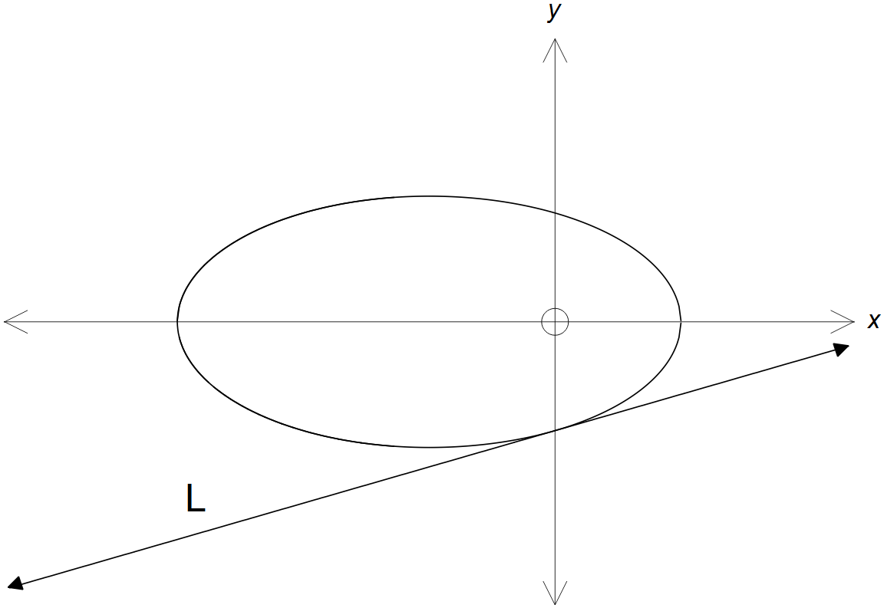

**Question 2 (10 marks)**

(a) Use De Moivre’s rule to evaluate ${\left(1+i\right)}^{5}+{\left(1-i\right)}^{5}$. (5 marks)

(b) State the sets that define each of the following loci.

(i) (2 marks)

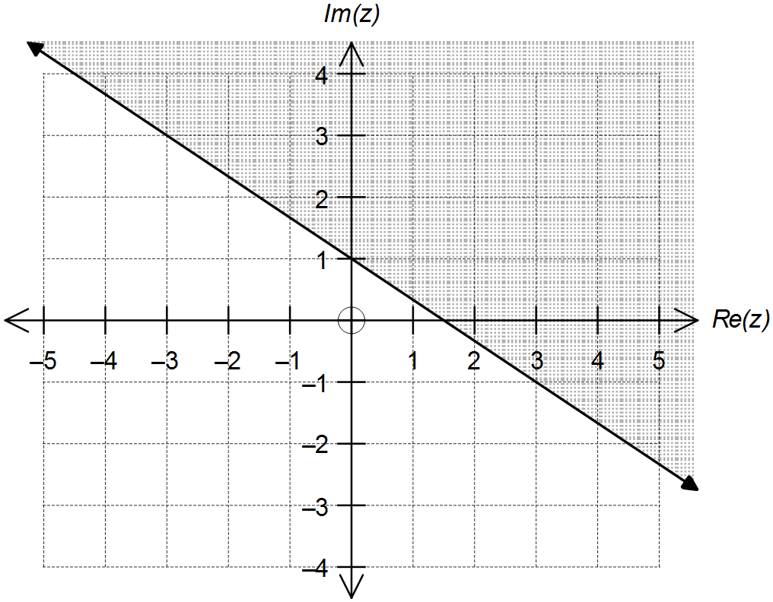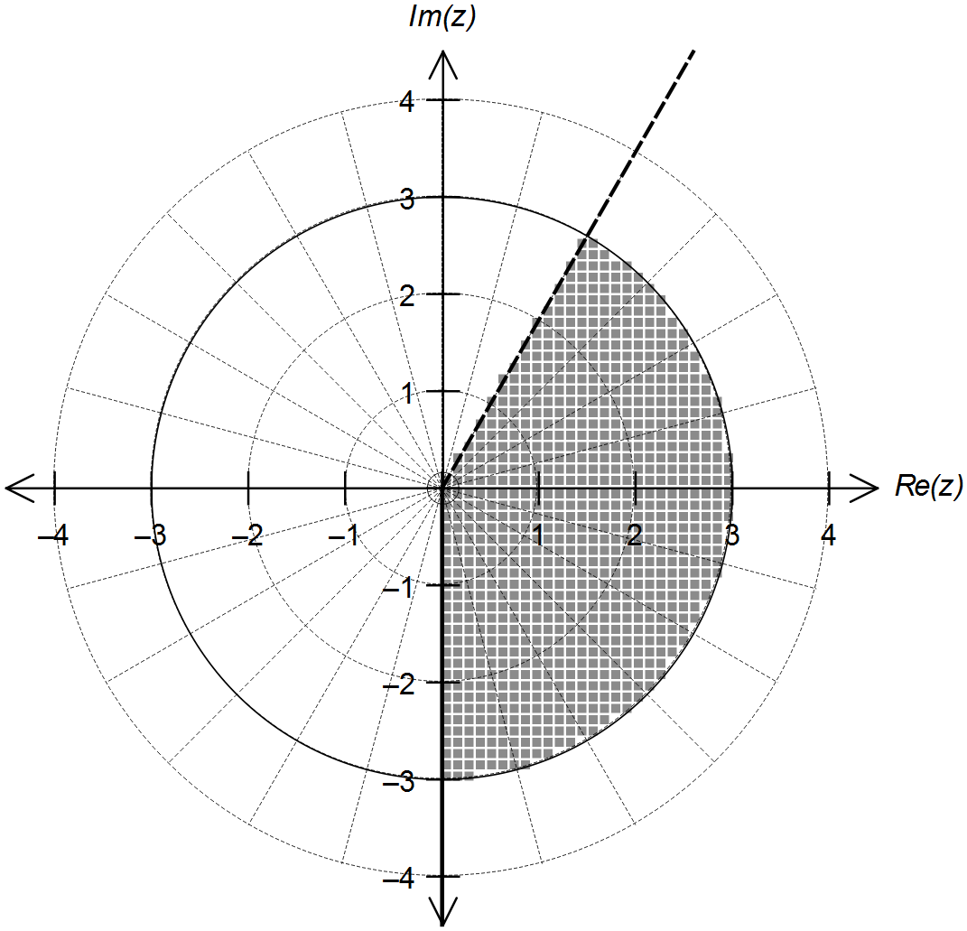

(ii) (3 marks)

**Question 3 (9 marks)**

(a) Determine: (4 marks)

$$\int{\cos{x}\left(1-\cos{x}\right) dx}$$

(b) Use an appropriate substitution to determine: (5 marks)

$$\int_{\frac{π}{6}}^{\frac{π}{4}}{\frac{\sin{(2x)}}{1+\cos{(2x)}} dx}$$

**Question 4 (12 marks)**

The function $f(x)$ is defined for $x≠0$ by: $f\left(x\right)=\frac{{2x}^{2}-3x+1}{x^{2}-x}$

(a) Use division of polynomials to express the function $f(x)$ in the format $f\left(x\right)=A+\frac{g\left(x\right)}{x^{2}-x}$

where $A∈R$ and $g(x)$ is a linear function.

(3 marks)

(b) Hence, or otherwise, sketch the graph of $f(x)$ on the axes provided below. (4 marks)

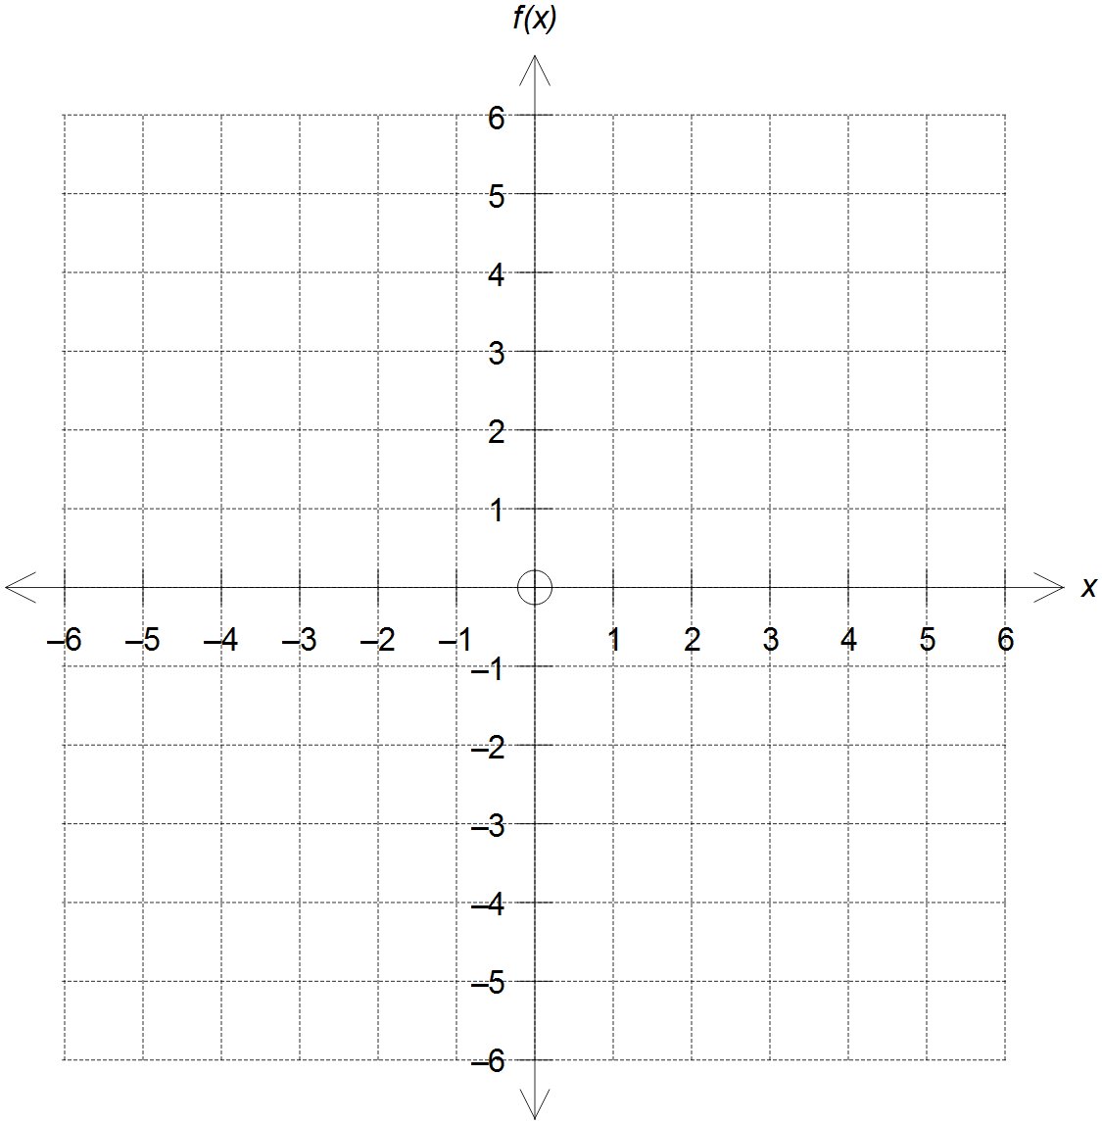

**Question 4 (Continued)**

(c) State the range of $f(x)$. (1 mark)

(d) Show that $f^{-1}\left(x\right)=\frac{1}{2-x}$ and state the domain of $f^{-1}(x)$. (2 marks)

(e) Sketch the graph of $f^{-1}(x)$ on the same set of axes in (b), clearly labelling all relevant

points and features.

(2 marks)

**Question 5 (7 marks)**

A region is bounded by the y-axis and the curves $y=\sin{x}$ and $y=\cos{x}$ as shown below.

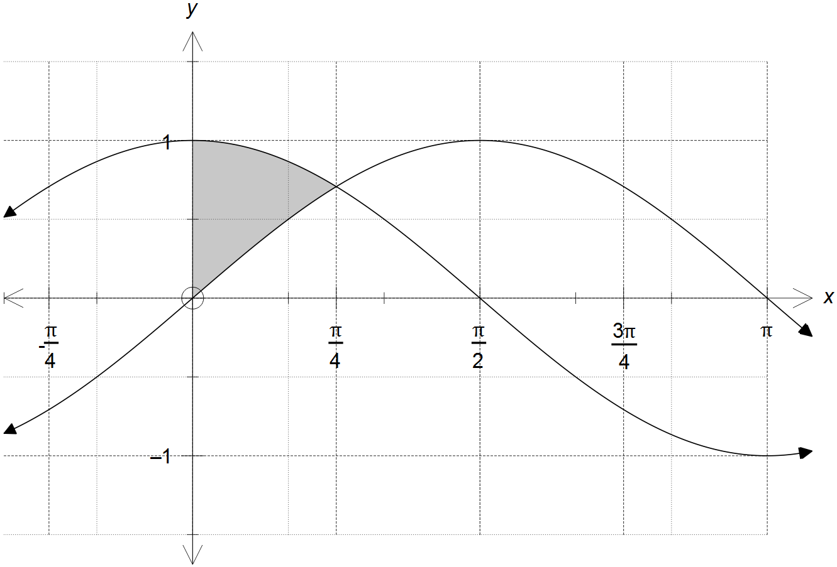

(a) Evaluate: (2 marks)

$$\int_{0}^{\frac{π}{4}}{\left(\cos{x}-\sin{x}\right)dx}$$

**Question 5 (Continued)**

(b) Calculate the exact volume of the solid generated by rotating the region shown in the

diagram around the x-axis.

(5 marks)

**Question 6 (7 marks)**

The coefficients of the system of linear simultaneous equations shown is represented by the matrix $M$, with $p,q∈R$.

$\begin{matrix}2x+y+z=1 \\ 2y+z=q-2 \\ -y-pz=10\end{matrix}$ ⇒ $M=\left[ \begin{matrix}2 & 1 & 1 \\ 0 & 2 & 1 \\ 0 & -1 & -p\end{matrix} \begin{matrix}1 \\ q-2 \\ 13\end{matrix} \right]$

(a) The matrix M can be simplified into the form shown below.

Determine $a$ and $b$ in terms of $p$ and/or $q$. (2 marks)

$$M=\left[ \begin{matrix}2 & 1 & 1 \\ 0 & 2 & 1 \\ 0 & 0 & a\end{matrix} \begin{matrix}1 \\ q-2 \\ b\end{matrix} \right]$$

(b) Determine the unique solution to the system of simultaneous linear equations for

when $p=5$ and $q=3$. (3 marks)

(c) Using your answer in (a), state the conditions on $p$ and/or $q$ so that the system of

simultaneous linear equation has:

(i) infinite solutions. (1 mark)

(ii) no solution. (1 mark)

**End of Questions**

**Additional working space**

Question number(s): ……………………

**Additional working space**

Question number(s): ……………………